STA 6013 Regression Analysis
Robert Santos

1 Introduction

For this project, I used the glass data from the USA Forensic Science Service. The intention of this dataset was to predict the glass type with the variables being refractive index and the concentration of eight different mineral oxides. Refractive index is a ratio of the speed of light in a vacuum over the speed of light based on what material it is passing through. This is essentially a speed limit for light based on what material it is passing through. This data originally had 214 observations, after I discussed it, I removed observations 31-50, which left us with 194 observations for the project. The original intent of this data was used to predict glass type with glass type being a qualitative response. Instead of this, I decided to model the refractive index using the mineral oxides.

2 Data Preprocessing

To begin the analysis, I obtained the ranges of the relevant variables:
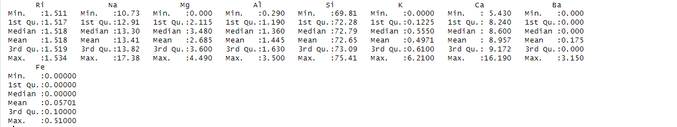
As seen in the table of data, the ranges for these variables are quite small. This low variability distribution can lead to issues down the line. For example – if the model used is complex – overfitting can result due to low variability for the variables. Another issue that can occur is the model may not be able to detect slight changes when modeling. Not only for this dataset, but for any dataset that has these kinds of ranges, the issues stated & several others can result due to low variability. Having tried scaling this during our model building, I determined that scaling did not strongly affect the model. Consequently, the variables Ire left as they Ire. Following this, I ended up looking at the histograms and boxplots for the variables.

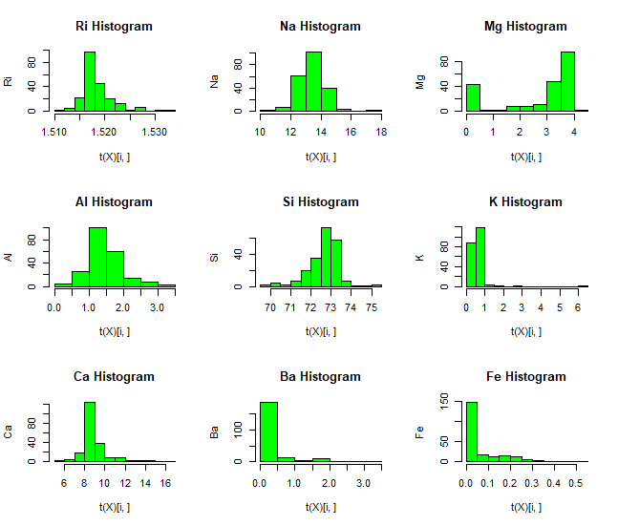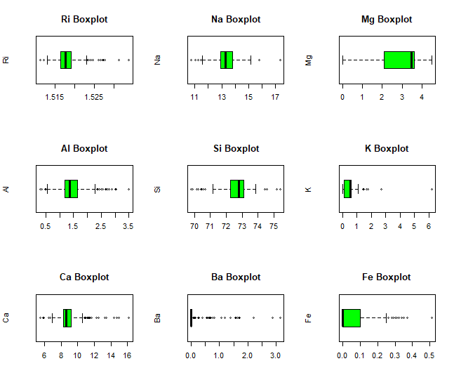
As seen in the figures above, the refractive indices for sodium, aluminum, silicon, and calcium follow normality with some skewness. Magnesium, potassium, barium, and iron do not follow normality: iron, potassium, and barium are skeId to the right. Looking at the boxplots, outliers exist in each variable except magnesium. To mention scaling again, I could’ve done scaling to help fix the visuals of the boxplots and the histograms, but as stated before, when doing the scaling in the model building, the impact it had on the model was minimal so I decided to leave them as is. For the outliers, this data pertained to the properties of chemical compounds of which I did not have knowledge. By extension, there was not enough statistical context in order to exclude the outlying points of data as in the plot below. As such, I decided to include the outliers as is.

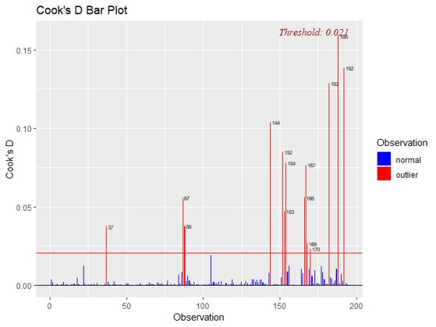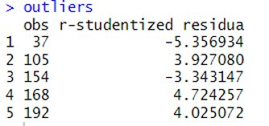
After doing this data preprocessing, I then decided to test our assumptions.

3 Assumption Testing

Prior to model selection, I wanted to make sure that this data set was appropriate for a regression model. There are various assumptions that need to hold for this to be a valid linear regression model. I first checked to see if the response, refractive index was normal. While this is not strictly necessary to obtain a least squares estimate, it can be beneficial for inference. Unfortunately, this model does
not have normally distributed errors.
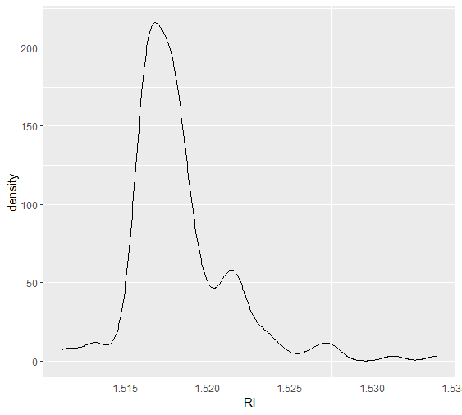
As you can see this distribution is heavily right skeId. I also ran the Shapiro-Wilks test, in this test the null hypothesis is normality. Our p-value was $3×{10}^{-12}$, so I must reject the null assumption of normality. I attempted some transformations to deal with this issue. Typically log or square root transformations would be helpful when dealing with a right skeId distribution. In our case both transformations Ire ineffective. The density plots of both transformations have a similar shape to the original response density. I ran the Shaprio-Wilks test with both transformations, the null hypothesis of normality was rejected in both cases.
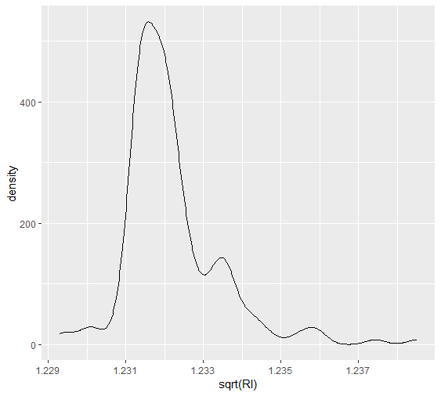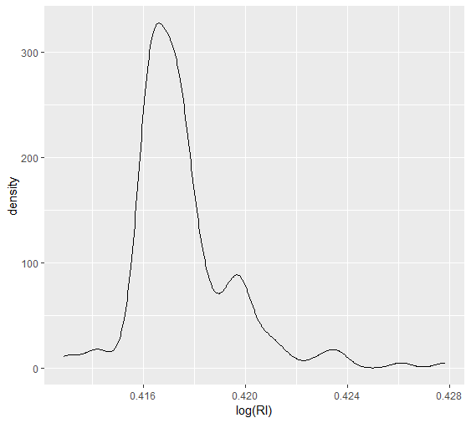

The next assumption I checked was homoscedasticity of the errors. To do this I fit a first order linear model with all predictors. The plot of the residuals vs. fitted values shoId a mostly constant variance with no obvious fan shape or curvature.
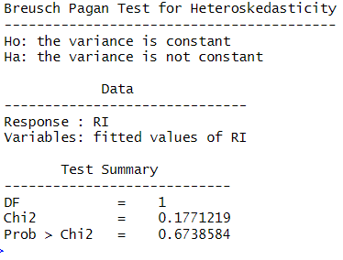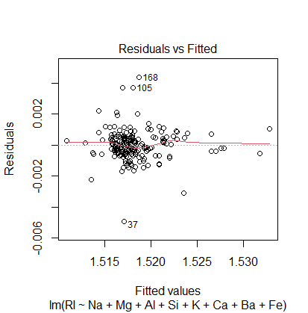
I also ran the Breusch Pagan test, in which the null hypothesis is constant variance. Our p-value was 0.6738, which means I do not have enough evidence to reject the assumption of constant variance. You will see in a later section that I removed some variables from the full model. I conducted the same analysis for our final model and will show it in our section on model validation.

Using all predictors, I checked for multicollinearity. There was a great deal of multicollinearity in the full model. Typically, VIF’s greater than five indicate the presence of high multicollinearity. The full model had VIF’s in excess of 200. 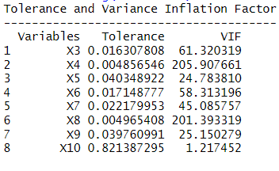
I also obtained the condition indices for the full model. Typically a condition index of over 100 is considered problematic. One of the eigenvalues is near zero and one of the condition indices of the full model is over 3000, which shows evidence of high multicollinearity. There are many ways to deal with high multicollinearity. I explored whether reducing the number of predictors would mitigate this issue.In the next section I will explore how I selected a smaller model.
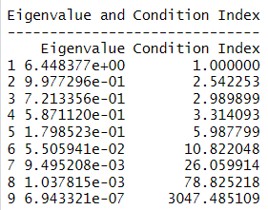

4 Model Building

I used forward, backward, and stepwise methods to generate possible models. All methods selected a five predictor model. The forward and stepwise models agreed on a model containing Ca, Si, Al, Ba, and Mg.
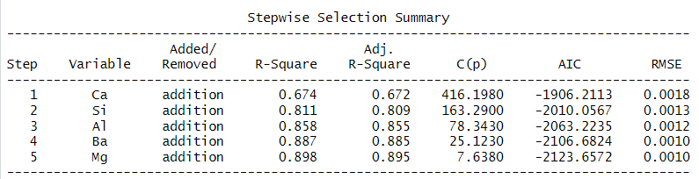
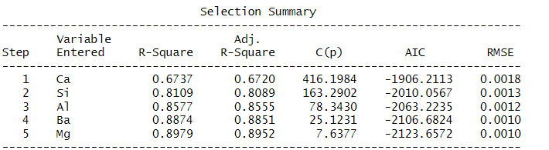
The backward elimination, hoIver, method produced a model containing Na, Mg, Ca, K and Ba. To decide betIen these two different models I ran regression models for all possible subsets of the predictors. The model produced by the backward elimination maximizes the adjusted R squared and minimizes the AIC and BIC. It does have a Cp statistic less than five which indicates that there is some bias.
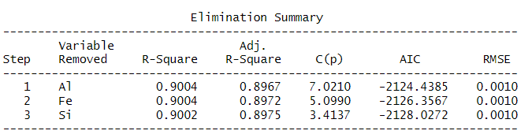
This model is clearly Ill fit, and it also has significantly improved multicollinearity properties. As you can see in the tables below, all of the VIF’s are less than five, the condition indices are less than 100, and the tolerances are all greater than 0.25. This indicates that the reduced model does not have multicollinearity issues.
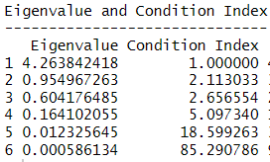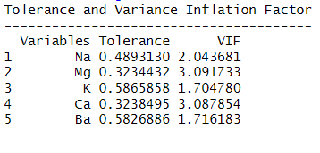

5 Model Validation

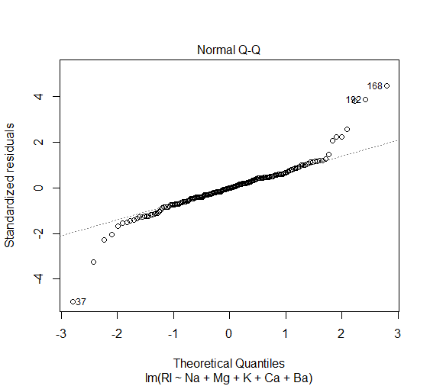
To begin the model validation, I wanted to test our models prediction accuracy. Using the predict() function in R, I generated predictions for the testing data based on the model fit using the training data. Once I got those predictions, I used those and the actual test data to calculate the MSE, which is 8.097277e-07. While our goal is to get the smallest possible MSE, this seemed too good to be true. Looking further I saw that the range of our response variable is from 1.5112 to 1.5339. 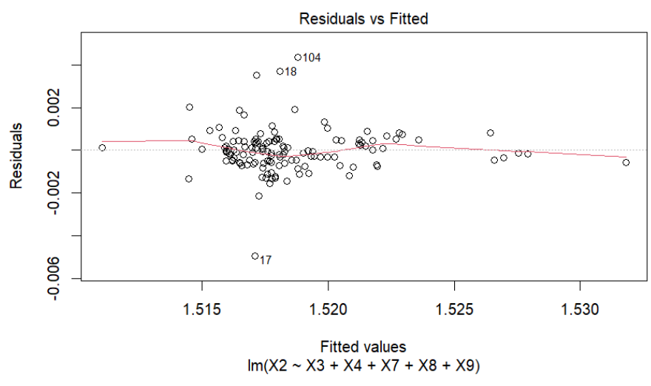

The next step in validating our model was to inspect the residuals. Looking at this Residuals vs Fitted plot, I see that there are a couple of outliers, but I decided to keep these in the data set since I are not familiar enough with this concept to determine that these outliers do not provide important information in this context. The pattern is not completely random, but it is scattered evenly enough around the zero line to indicate that the model’s predictions are mostly correct. I also repeated the Breusch Pagan test with this model and achieved a p-value of 0.56, which means I lack evidence to say that the residuals are not homoscedastic. Unfortunately, this reduced model has the same issue of non-normality of the residuals. As you can see from the above qq-plot, the residuals follow a heavy-tailed distribution. I attempted various transformations to correct this issue but I Ire not able to achieve any improvement.

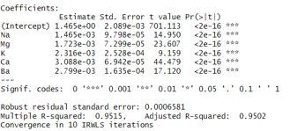
Continuing on with the validation, I wanted to check the robust regression. Since 7% of our data are outliers, I decided to conduct a robust regression using the IRWLS method. Looking at the summary output for this, I see that the 5% more of the variance can be explained by the explanatory variables and the coefficients for the model are practically the same.

6 Conclusion

To reiterate the more important points of this analysis, I saw that our data met all of the assumptions for a linear regression. After many attempts at transformations and different selection methods, our best model came from the best subset selection with no transformed variables. From that I got the following equation:

RI = 1.47 + (.0012)Na + (.00168)Mg + (.00119)K + (.00295)Ca + (0.00278)Ba​

Since all of the coefficients are positive, I know that there is a positive relationship betIen each of these predictors and the refractive index of the glass. Our final model was the best that I could get for this data because of all our attempts it had the loIst AIC and MSE, as Ill as a high prediction accuracy. The R^2 value is 0.9002 and the adjusted R^2 is 0.8975, which means that 90% of the variance can be explained by the explanatory variables.

Glass has a plethora of uses, so it is often manufactured with specific optical properties in mind with the goal of achieving a predetermined purpose. Our model has the ability to give manufacturers insight about how certain quantities of Na, Mg, K, Ca, and Ba will influence the refractive index of glass.

